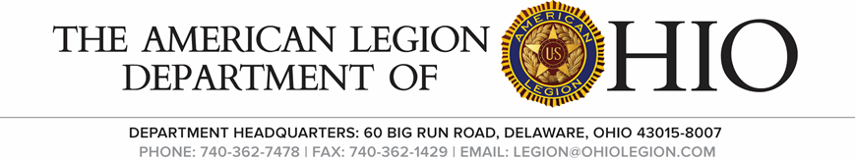

Joint National Security & Legislative Committee Meeting

Friday , March 12, 2020, Crown Plaza, Columbus. OH.

Minutes
The meeting was called to order at 4:00 pm by Chairman Buxon at Mid-Winter Conference in Columbus, Ohio. Salute to the colors. The invocation was given. The pledge of allegiance was led by Chairman Buxton (D-4). _____________ took the minutes.
Roll Call:
Dist. 1 Michael Kennedy- Present, Dist. 2 John McJunkin- Present, Dist. 3 Robert Weiler – Present, Dist. 4, Al Buxton, Chairman - Present , Dist. 5 Bill Edwards - Present, Dist. 6 Scott Horsington, Present Dist. 7 Rick LaValley - Present, Dist. 8 Robin Johnson - Present, Dist. 9 Jose Rivera - absent, Dist. 10 Douglas Russell, Present Dist. 11 Tom Leach, Present Dist. 12 Bernie Brogan - Present, Dist. 13 Richard Wright - Present.

Greetings:

Review of Minutes:
After review, a motion was made by Tom Leach and second Rick La Valley to accept the minutes as written.

New Business
House Bill V/A to vaccinate all veterans and spouses was discussed.

House Bill #VA vaccine application (COVID) HR#1276 – VA Vaccine Act.
Motion made that Legion backs the bill. HR#1276 passed the house only. Richard Wright 13th District made motion to accept the bill and Rick LaValley second and the motion passed.

Legislative Portion of the meeting convened at 3:30PM.

Ken Lavoy – Legislative Meeting Dispensed minutes of last meeting.
Rick LaValley moved to accept the minutes
Jason Larue second and motion passed.

House Bill #190 prohibits a war relic from being destroyed – motion made to have Legion support this bill.
Mike LaValley moved to support this motion. Jason LaRue seconded and motion passed.

New Business: None

Unfinished Business: None

Good Of The Legion: None

Salute to the Colors was rendered. The meeting adjourned at 4:55pm.

