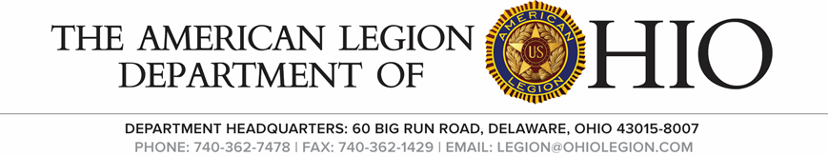
Membership Call-in Meeting
Wednesday, Nov. 9, 2022

Agenda

- Call to Order Chairman 1st Vice Rue

- Salute the Colors Chairman 1st Vice Rue

- Invocation Asst. Chaplin Al Buxton

- The Pledge of Allegiance Chairman 1st Vice Rue

- Roll Call Adjutant Robinson
1st Kevin Motter
2nd Thomas Tierney
3rd Ken LaVoy
4th Al Buxton Jerry Perry
5th Marty Moore
6th Shane Eaton
7th
8th
9th Bill Dittebrand
10th
11th Thom Stan
12th George Mussi
13th Bert Boyd
14th

- Opening Remarks Chairman 1st Vice Rue
Commander Rue
We need to reach out to the members we already have. Find out why they did not renew and work on renewing them.

District 1 Contacting Post to process their membership
District 2 Contacting the Post to make sure cards are processed
District 3 Divided the dist. And do weekly round-ups of the posts
District 4 Send out membership report to each Post & email upcoming news
District 5 Did a membership round-up, and we are calling posts
District 6 Email to post and explain membership to them
District 11 Making phones calls and urging Post to turn in membership
District 12 is sending letters to help renew
- Unfinished Business
None
- New Business
Resolution From District 10 Shane Eaton 6th Dist. Made a motion to accept Thom Stan 11th Dist 2nd. The motion passed unanimously

- Good of the Legion
1st Vice Commander Rue Continue to help your Post with membership communication is the key to successes

- Benediction Asst. Chaplin Buxton

- Adjourn

