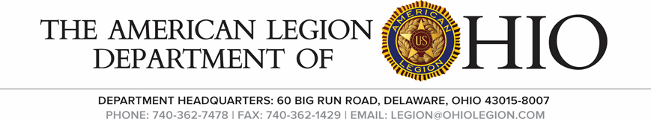
I.A. Commission Meeting
Saturday, March 11, 2023

- Call to Order Chairman 1st Vice Rue

- Salute the Colors Chairman 1st Vice Rue

- Invocation Adjutant Robinson

- The Pledge of Allegiance Chairman 1st Vice Rue

- Roll Call Adjutant Robinson
1st Jason Rue P
2nd Kent Long Excused
3rd Chris Emmons P
4th Jerry Perry P
5th Charles Kvochick P
6th Bart Arndt P
7th Mike Holz Excused
8th Fred James A
9th Bill Dittebrand P
10th Holly Lewis P
11th Andrew Matheny P
12th George Mussi P
13th Mel Baher P
14th Steve Masowick P

- Opening Remarks Chairman 1st Vice Rue
Commander Rue
Thank you for attending the meeting

- Unfinished Business
Resolution for the “Fredrick W. Galbraith Award” returned to the district for further clarification.

Post Inspection Form Changes
They recommended taking off the post number on the first line as it is stated three lines lower. It was asked to change the due date to February 1 of each Year.
Line (9) Total Post Dues___________
Line (12) should have Buddy Check added to the programs we work
Line (13) A definite Membership effort ___ is Maintained___is not Maintained.
(14) Post has Legion Riders Chapter____Yes_____No
(15) Post has SAL____Yes____No
A. If (YES), Indicate all forms that have been turned in for the Current Year.
(16) Post have an Aux Unit_______Yes_____No
(17) Post has a Canteen _____Yes _____No
A. What hours open & Days Open__________________
B. Gaming License_______yes ______ No
Holly Lewis made a motion for these changes, seconded by Charlie Kvochick

- New Business

- Good of the Legion
1st Vice Commander Rue
He thanked everyone for their remarks throughout the meeting and for attending.
Chris Emmons said the next meeting would fall during the Legion Baseball Tournament.

- Benediction Adjutant Robinson

- Adjourn

