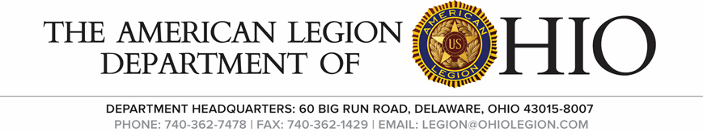
I.A. Commission Meeting
SAturday, Oct 1, 2022

- Call to Order Chairman 1st Vice Rue

- Salute the Colors Chairman 1st Vice Rue

- Invocation Interim Adjutant Robinson

- The Pledge of Allegiance Chairman 1st Vice Rue

- Roll Call Interim Adjutant Robinson
1st Jason Rue
2nd Kent Long
3rd Chris Emmons
4th Jerry Perry
5th Charles Kvochick
6th
7th Mike Holz
8th Fred James
9th Bill Dittebrand
10th Holly Lewis
11th Andrew Matheny
12th George Mussi
13th Mel Baher
14th Steve Masowick

- Opening Remarks Chairman 1st Vice Rue
Commander Rue
Thank you for attending the meeting

- Unfinished Business
Resolution for the “Fredrick W. Galbraith Award” returned to the district for further clarification.

- New Business
Interim Adjutant Robinson went over the scope of the Commission.
Post Inspection form. Changes to be made
Form to be turned in by Dec 31 each year.
Have Post forms been turned in (Officer Cert. CPR Annual Data Report)
SAL, if Post has one, have their forms turned in.
Does the Post have a Surety Bond for members and employees
Does the Post have rifles, and how many do they have? What type of weapons are they?
Has the Post completed their 990
Remove Post Officers List

- Good of the Legion
1st Vice Commander Rue
Thanked everyone for their remarks throughout the meeting and for attending.

- Benediction Interim Adjutant Robinson

- Adjourn

