Gifts for Yanks Meeting Minutes
Meeting held at
American Legion, Department of Ohio
60 Big Run Road, Delaware, Ohio 43074
6-2-2018
The meeting opened at 10:00AM by Chairman Bishop. The Flag was saluted, a prayer given by Chairman Bishop, and the pledge was given.
Holly Lewis was appointed as the secretary.
Roll Call
District 1 | Chet Kendzierski (Present)
District 2 | Paul Maurer (Present)
District 3 | Bob Steggemann (Present)
District 4 | Ken Ellis (Present)
District 5 | Darrell Bishop (Present) (Chairman)
District 6 | Daniel Goodman (Excused)
District 7 | John Barnhart (Excused)
District 8 | Mick Williams (Present)
District 9 | Bill Keller (Present)
District 10 | Holly Lewis (Present)
District 11 | Floyd Burk (Present)
District 12 | Jerry Laird (Excused)
District 13 | Stanley Popek (Excused)
District 14 | Dale Luzader (Excused)
Department Program Administrator | Jared Hickle (Present)

Chairmen Bishop’s Remarks
Jared Hickle was introduced as the Department Program Administration replacing VA&R Director/Interim Adjutant Suzette Heller. Chairman Bishop stated that it was a disappointing year for many reasons, including declining fundraising. This was partly due to lack of marketing to the Posts, insufficient reporting, and the change of the financial year which caused confusion. We will be correcting these issues moving forward.

Review of Subcommittee Meeting Minutes
$10,000 for stand downs have been moved to Special Projects so that the funds need to be requested.
$500 for each Vet Centers have been moved to Special Projects so that the funds need to be requested.
Added additional clinics for funding in budget since they now have a VAVS representative.
Budget was initially set at $260,000; subcommittee revised to $200,000 due to reduced fundraising.

Finances/Donations
Reviewed Donations by District
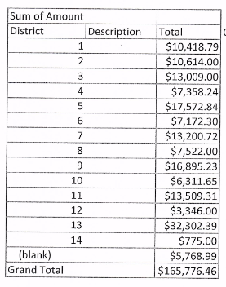
Chairman Bishop praised District 13 and specifically the Parma Post for their fundraising efforts. Chairman Bishop noted that donations are still being accepted until July 31, 2018 and that these funds will be used for next year’s program. A budget will be presented to the Finance Committee at Department Convention.
A list of each Post’s donation was given to each District Chairperson to give out the plaques for the highest donors to Gifts for Yanks by category.

Gifts for Yanks Total Finances
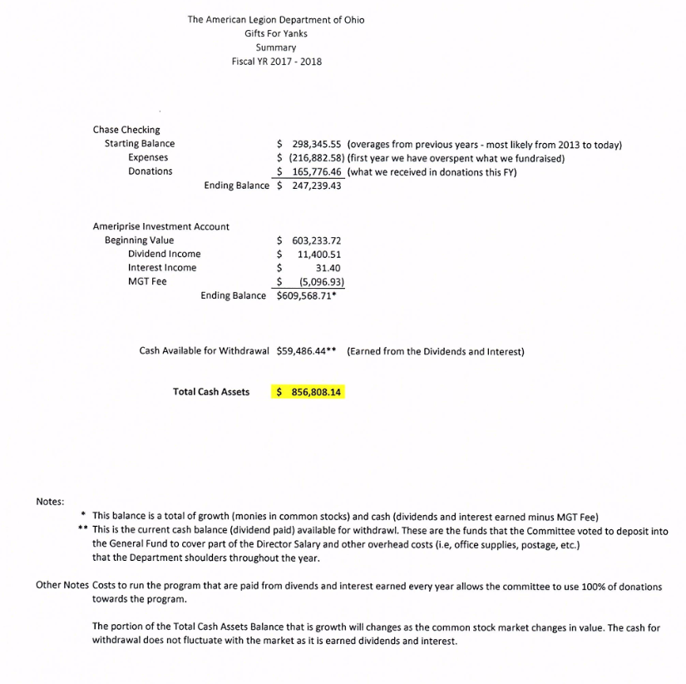
Chairman Bishop noted that the Gifts for Yanks program gives 100% of all donations to veterans. We are using interest income to pay for administrative costs, postage, and a portion of Department Staff wages that are used by the Gifts For Yanks Program. We are waiting on a figure for our portion so that we can add it to the budget.

GFY User Manual
First portion is complete. Guidelines will be edited to be by category. Subcommittee changes will also be added. Working towards August 1, 2018 for completion.
Fundraising Status
Chairman Bishop discussed the fact that we need to give a receipt to all donors according to the IRS. We will be sending a Thank You Donor Letter for the all donation. Chairman Bishop proposed that we send out a Gifts for Yanks Screen Cleaner with each donor’s first donation letter. Floyd Burke (11) made a motion to purchase 1,000 screen cleaners to include with the donor letter; seconded by Paul Maurer (2). All were in favor.
Chairman Bishop discussed the certificates and proposed changes to how they will be handled. The changes are to save on postage and administrative overhead.
- Blue Certificates for Posts will be pre-filled except for Post # and Contribution for District Chairpersons fill in and hand out.
- Tan Certificates for Individual Contributors will be pre-filled except for name of donor. Department will mail these to the District Chairmen.
- Gold Certificates – will still be handled by Department of Ohio.
Ken Ellis (4) made a motion to approve the changes in certificates; seconded by Bill Keller (9). Discussion followed. All in favor.
Chairman Bishop reviewed the expenditures for the year. Georgetown got the second portion of their funding for a new van. Total expenditures are $114,761.22 for the year so far. VAVS can request reimbursement for expenditures but must have receipts, and proper request for reimbursement form.
Chairman Bishop reviewed the proposed budget of $200,000. We added more clinics since they now have a VAVS representative. The Vet Centers do not have a VAVS representative. We moved these to special projects so that overseeing body can request funds for the Vet Centers.
Chairman Bishop reviewed the gift for this year; all made in the USA except one:
- Grey Shaving Bag
- Rubber Grip Pen
- Stress ball (doubles as a screen cleaner)
- Refillable Journal (Made in China, but the tag is hard to locate. Must remove journal, lift flap to read)
Bill Keller (9) made a motion to accept the proposed gift; seconded by Chet Kendzierski (1). All in favor.
Chairman Bishop reviewed the Special Projects selected by the subcommittee:
- Vet Centers and Homeless Veteran Stand Downs - $13,500
- Cleveland VA - Arts Initiative $2,000
- Lorain CBOC - Veterans/Women Veterans cookouts, 2 iPads for registration $2,038
- Canton CBOC - Fishing Trip $2,000
- Dayton VA – Yoga, Woodcarving, ceramic, craft supplies $3,700
- Chillicothe – Greenhouse Project $5,500
- Cincinnati – Arts Program $5,000
- OVH Georgetown – Scooter $1,600
- OVH Sandusky – Rocking Chairs - $5,000
- Columbus ACC – Veterans Art Initiative - $2,500
Bob Steggemann (3) made a motion to approve the Special Projects; seconded by Floyd Burk (11). All in favor.
Chairman Bishop discussed the plan for marketing. District Chairpersons will get marketing supplies for Posts at our first meeting so that we can reduce postage.

Unfinished Business
None.
New Business
Chairman Bishop discussed purchasing two American Legion Gold Coins to be raffled off to raised money. He expects that they will be $500-600 each. We can sell tickets at all the Department events and each district chairperson will receive tickets.
Mick Williams (8) made a motion to buy two sets of American Legion Gold Coins to be raffled off; seconded by Bill Keller (9). Discussion followed. All in favor.
Chairman Bishop discussed the Veteran’s Court project which is expected to be the Department Commander’s project next year. It is proposed that Gifts for Yanks oversee/sponsor this as a special project with a separate account funded by donations to the Commander’s Project. We currently have eight (8) veteran’s courts with certified Legionnaires involved.
Chet Kendzierski (1) made a motion to create a new special project for Veteran’s courts with certified Legionnaires; seconded by Ken Ellis (4); discussion followed. All in favor.
Chairman Bishop discussed the fact that we are not marketing Gifts for Yanks to our 888 members. Would like to pilot some marketing to 2,000 of the 888 members for one year to request donations. We can expand next year if successful.
Ken Ellis (4) made a motion to pilot marketing/donation requests to 2,000 888 members for one year; seconded by Holly Lewis (10). Discussion followed. Ken Ellis (4) amended the motion to not exceed $1,000 for postage and materials for one year; Holly Lewis (10) seconded. All in favor of amended motion. All in favor of original motion.
Mick Williams (8) asked how the pilot for service officers handing out memberships went. Chairman Bishop noted that he will have results of who renewed at our first meeting.
Plaques and certificates for donations were handed out to each District Chairperson. A discussion was had regarding the pins. Two pins should be given with each Post certificate. The District Chairperson, with the permission of the District Commander, can use the pins to gather additional donations.
Suzette Heller came in for short remarks expressing her confidence in Jared and further explaining the Veteran’s Court initiative.
Chairman Bishop closed the meeting at 11:59AM.

