**Order Your 100th year Department of Ohio Convention Shirts Today!**

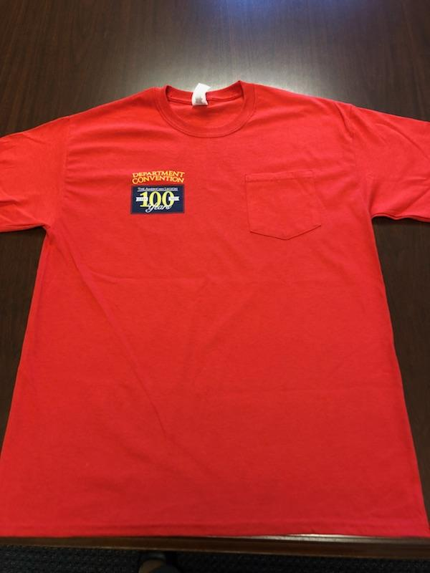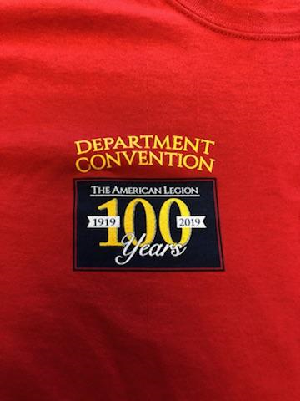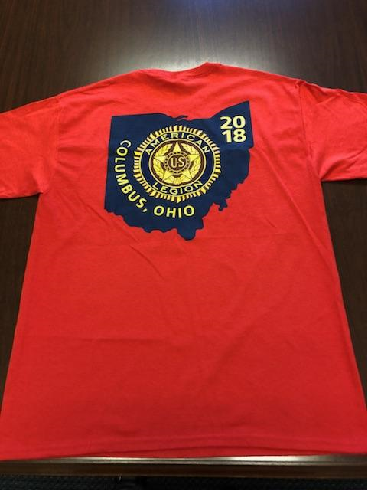

**Each 100th year Convention T-Shirt comes with a pocket on the left side and a unique Department of Ohio design on both the front and back.**

**Unit Price: $20.00 for any size!**

**(We Accept Cash, Credit & Checks Made Payable to: The American Legion Dept. of Ohio)**

Please write the **#** of shirts you would like to order next to the size of your choice:

**Med: ______ Large: ______ XL: ______ 2XL: ______ 3XL: ______**

Amount Enclosed: ________ Check #: ___________

Name: _________________ Post #_________ Phone: ____________________

Shipping Street Address: _________________ City: _______________________

State: ____ ZIP: ________ Email: _____________________________________

**Credit Card Use Only**:

Full Name on Card: ______________________________________________________

Card #_______________________ Exp. Date: __________

CVV (code on back): _____ Billing Street Address: __________________________

City: _______________ State: _______ ZIP: __________

Please mail your completed order form and payment to: **The American Legion Department of Ohio**

**P.O. Box 8007 / 60 Big Run Rd. Delaware, OH 43015**