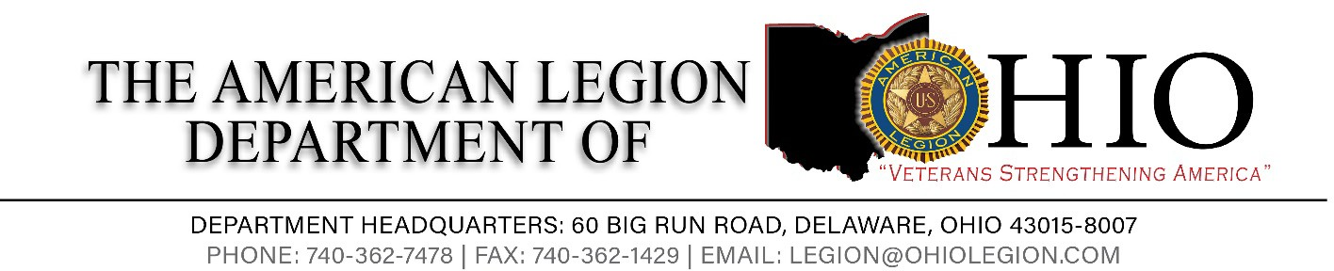

DEPARTMENT EXECUTIVE COMMITTEE MEETING
Saturday, August 5, 2023 Department Headquarters
60 Big Run Rd, Delaware, OH 43015
Wi-Fi American Legion Guest -Password Legion 2022

Opening
- Call to Order: Jason Rue, Department Commander
- Salute to the Colors
- Invocation: Ron Distel, Department Chaplain
- Pledge of Allegiance: AJ Whatley, Department First Vice Commander
- Preamble: AJ Whatley, Department First Vice Commander
- POW/MIA Recognition: Stan Oren, Department Second Vice Commander
- Roll Call: John Robinson, Department Adjutant
- Introduction of Guests: Dean Boyers, Department Sergeant-at-Arms
- Reading of previous minutes: John Robinson, Department Adjutant

Officer Greetings
- Jaason Rue, Department Commander (Opening DEC Remarks)
- AJ Whatley, Department First Vice Commander, Membership Chairman
- Stan Oren, Department Second Vice Commander, Post Activities Chairman & Internal Affairs
- Jose Rivera, Department Treasurer
- Ron Distel, Department Chaplain
- Al Beyer, Department Historian
- Steve Masowick, NEC
- Ron Chapman, Alternate NEC
- Josh Brown, Department Judge Advocate
- Gary Minadeo, Department Parliamentarian
- John Robinson, Department Adjutant
Committee Commission Reports: Jason Rue, Department Commander
- Christie White, Americanism Commission Coordinator
  - Christie White, Department Baseball Coordinator
- Christie White, Children & Youth Commission Coordinator

- Jose Rivera, Finance Chairman
- William Genochio, Legislative Commission Coordinator
- William Genochio, VA&R Commission Coordinator
- Jon Vulgamore, Media Marketing & Communications Commission Coordinator
- Hunter Woods Post Activities Coordinator
  - Hunter Woods, Gifts for Yanks Committee Coordinator
- John Robinson, Sons of The American Legion Report
Brake For lunch
Post Charter/Revocations, Suspensions: John Robinson, Department Adjutant
- Suspensions
- Post 401 update
- Closings
- Post 472

Resolutions/Constitutional Amendments – Jason Rue, Department Commander

- Nothing to Report at this time

Unfinished/New Business
- Unfinished Business
- Ratification of Internal Affairs Commission members
- New Business

- Good of the American Legion/Announcement
  - 105th Department Convention: Christie White, Holiday Inn Independence July 11-14, 2024
  - “Of The Year” Award Deadline
  - National Convention: John Robinson, Department Adjutant August 25 – August 31, 2023, Charlotte, NC

Closing

- Closing Remarks: Jason Rue, Department Commander
- Benediction: Ron Distel, Department Chaplain
- Salute to the Colors
- Adjourn

