THE AMERICAN LEGION
Department of
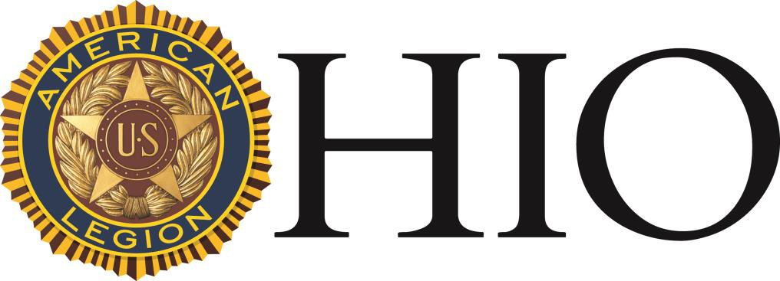

Child Welfare Worker of the Year Award 2023-2024

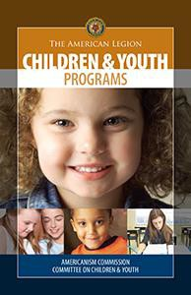

60 Big Run Road ♦ Delaware, OH 43015 Phone: 740-362-7478 ♦ Fax: 740-362-1429
www.ohiolegion.com

HISTORY & INSTRUCTIONS

The Department of Ohio Children & Youth Commission created the Child Welfare Worker of the Year Award to recognize those front-line civilian warriors who work tirelessly on behalf of children every day.

The successes of those who have received this award are the youth who emerge as productive tax paying citizens from all walks of life that may be underserved and at-risk of basic needs of shelter and food. These children may suffer from poverty and broken homes filled with abusive or dysfunctional families that rely upon care and resources distributed, or administered, by the selfless this award recognizes.

Each year, the award recipient chosen by the Children & Youth Commission will receive an award with their name and year ascribed onto the plaque. They will be notified, and the award will be presented at the Mid-Winter Conference Awards Ceremony.

Eligibility and Selection

- The Ohio American Legion Child Welfare Worker of the Year Award is open to professional or volunteer youth counselors throughout Ohio who demonstrate outstanding devotion to the ideals of The American Legion and provide children of Ohio with positive direction.

- Nominations must be submitted to Department Headquarters by September 15th. Nomination forms available on the Department website: www.ohiolegion.com/of-the-year-awards/. Those permitted to nominate include Post officers, County officers, District officers, Department officers and the Department Children & Youth Commission. Acceptance of nominations submitted by anyone other than those noted above will be at the discretion of the Department Children & Youth Commission.

- The Department Children & Youth Commission will review and judge award nominations in October each year. The recipient will be invited to receive the award at the annual American Legion Mid-Winter Conference.

- Selection of the recipient will be based upon judging criteria established by the Department Children & Youth Commission and amended as may be deemed necessary, subject to the approval of the Department Executive Committee.

NOMINATION FORM

2023-2024
THE OHIO AMERICAN LEGION

NOMINEE DATA

- Name of Nominee
- Address
- City, State & Zip Code
- Telephone number: Daytime ( ) -
Evening ( ) -
- Title
- Employer
- Nominees Authorization
Signature
Child Welfare Worker of the Year

NOMINATOR DATA

- Nominator
- Address
- City, State & Zip
- Telephone number: Daytime ( ) -
Evening ( ) -
- Post Number District City
- Legion Office
- Signature of Nominator

III. NOMINATION CRITERIA | For Selection Commission Use Only  POINTS POSSIBLE AWARDED
To be completed by Nominator  - Years of Services  - Average number of children served each year  - Brief description of services provided  Check one: Professional Volunteer  - Other honors or awards received  - Articles published  - Why is this nominee exceptional above others providing similar services  - Nominees achievements for which nominated  - Supervisor’s Name  Title Address  Supervisor’s Authorization  Signature | 1. 5  2. 10  3. 5  4. 20  5. 10  6. 25  7. 20  8. 5
 | TOTAL 100

