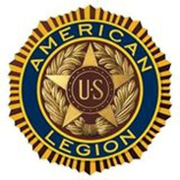
Buckeye American Legion College
Presentation Evaluation Form

Participants: Your opinion matters. Please fill out the survey below. Mark one answer for each question and fill in your response in the space provided.

Presenter: __________________________________ Date: _________________

Topic: _________________________________________________
Excellent----------------Neutral--------------Needs Work
To what extent did the presentation represent the following features? | 5 | 4 | 3 | 2 | 1
- Purpose communicated clearly
- Organized and easy to follow
- Presenter exhibited a good understanding of topic
- Presenter was well-prepared
- Presenter spoke clearly/effectively
- Time for presentation used effectively
- Slides enhanced presentation
- Presenter responded effectively to audience questions and comments
- Presentation was done in a way that engaged audience

- What did you like most about the presentation?

- What areas might you suggest for improvement not listed above?

