70th Annual Joseph E. Annick State Bowling Tournament

2019 Registration Form
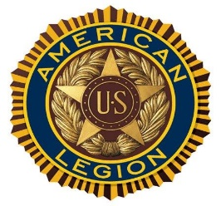

Tournament Dates: * February 2nd and 3rd *February 9th and 10 the *February 16th and17th

Date choices are not guaranteed and are first come first serve*
Registration Deadline: January 18th,2019

*Special Requests for 5 PM team event only will be available on Fridays (February 1st, 8th or 15th)

Doubles and Singles Squad Shifts: *Saturday, February 2nd @ 1PM and 4PM *Saturday, February 9th @ 1PM and 4 PM *Saturday, February 16th @1PM and 4PM
Team Squad Shifts: *Sunday, February 3rd @10 AM *Sunday, February 16th @ 10 AM *Sunday, February 17th @10 AM PM

